**Factory Reset of the PA 220 Firewall**

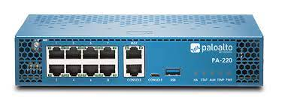

**Purpose,** for this lesson we will factory reset the PA 220 Firewall. Meaning that we will reset it to the out of the box configuration.

**Background information on lab.**

The Palo Alto Networks PA-200 is a true desktop-size platform that safely enables applications, users, and content in your enterprise branch offices at throughput speeds of up to 100 Mbps. Dedicated computing resources for the functional areas of networking, security, content inspection, and management ensure predictable firewall performance.

Lab Summary: Throughout this lab we will manage the physical interface of the PA 220 and then reset the PA 220 to its factory default settings. To do this we used our serial to USB cable to the console port of the PA 220 and we connected a internet cable from laptop to the firewall, Ethernet 1/1. We then launch putty to be able to enter commands into the command line. Make sure to plug in the firewall after launching Putty on the correct interface to ensure you can enter the prompt to enter maintenance mode. To reboot the PA220 enter the command

*Request system shutdown*

This will bring up a prompt asking to verify if you want to shut down. Say Yes and enter “y” after waiting a few minutes the PA-220 will reboot

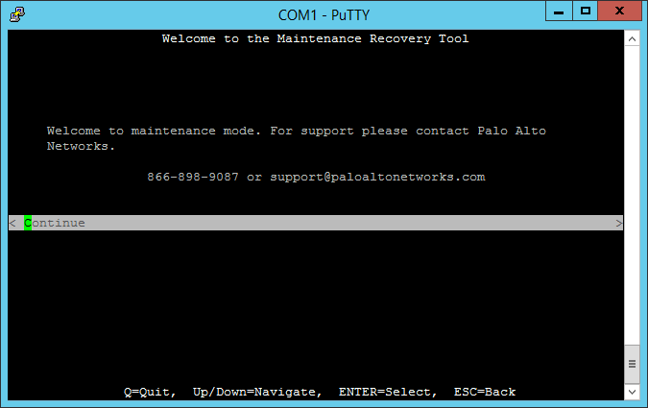

When prompted enter “Maint” to enter maintenance mode. After maintenance mode boots up (which may take a while) enter into the Factory Reset section and then click confirm, this will reset the PA 220 to its factory default settings.

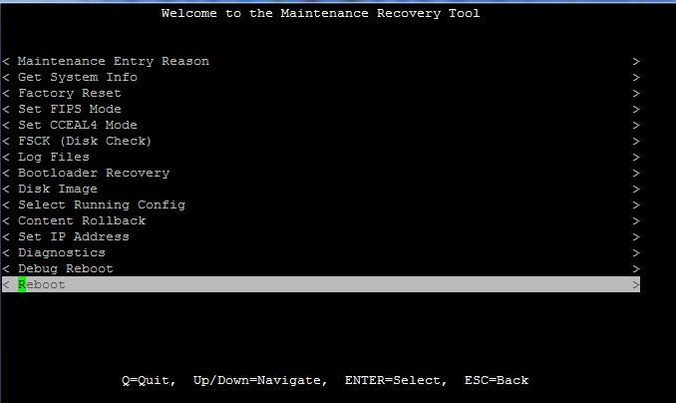

Upon rebooting after the factory reset enter the username and password admin, admin

**Problems**: The prompt to enter Maintenance mode would occasionally not show up when the Pa 220 was reset and had to be rebooted again.

**Conclusion:** The 220 Palo Alto firewall was easy and simple to reset. The GUI for Maintenance mode was clean and manageable. Overall, I loved the Pa 220 command line interface and am interested to know how the rest of the configurations feel.